Visual Studio Publishing

Author: Randall Stapleton, April 2023

# Description

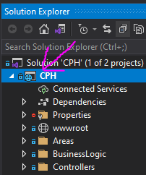

Image

This document presents the steps to follow to publish the application. Publishing is necessary to create a deployment-ready file structure.

# Startup.cs

Ensure that Configuration.GetConnectionString(“LiveConnection”) at approximate line 82 of the Startup.cs file references a functional connection string. Failure to do this will result in an error 500 when attempting to load the application’s web pages.

Note that the “LiveConnection” can be changed to a “DefaultConnection” value to have the program use the development connection string.



Image

# Framework Version

Knowing which framework version the application is using is crucial. To check the application’s framework version, right-click on the applications root file in Visual Studio’s Solution Explorer and click properties (Image 1). In the properties menu, observe the target framework selected value. This value represents the application’s framework version (image 2). This value can be changed to target new frameworks if needed.



Image

# Publishing

Once preparations are complete and the file is ready for deployment, it can be published. Publishing packages the application so that it can be installed on a web server.



Image

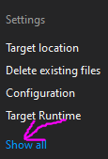

Image

* The publishing workflow starts by right-clicking the root file within Visual Studio’s Solution Explorer and clicking publish (Image 1). The Publish window will appear. For our purposes, we will select the Folder option (Image 3).
* Click the Next button, choose a folder to publish to, and click Finish. This will create a publishing profile with saved settings that can be reused later.
* Speaking of settings, click the “show all” settings button in the settings section (image 4). These settings will allow for changing framework versions and connection strings.
* There is also a setting to delete the previously published folder when starting a publish. Before moving on, be sure that the connection string is set.
* Now click save and click the publish button (Image 5).

The publishing process might take a moment. Once it completes, the published project will be in the selected folder. Once the project is published, the publish folder is ready to move to the web server.